West Hull Ladies
RRC

August Newsletter

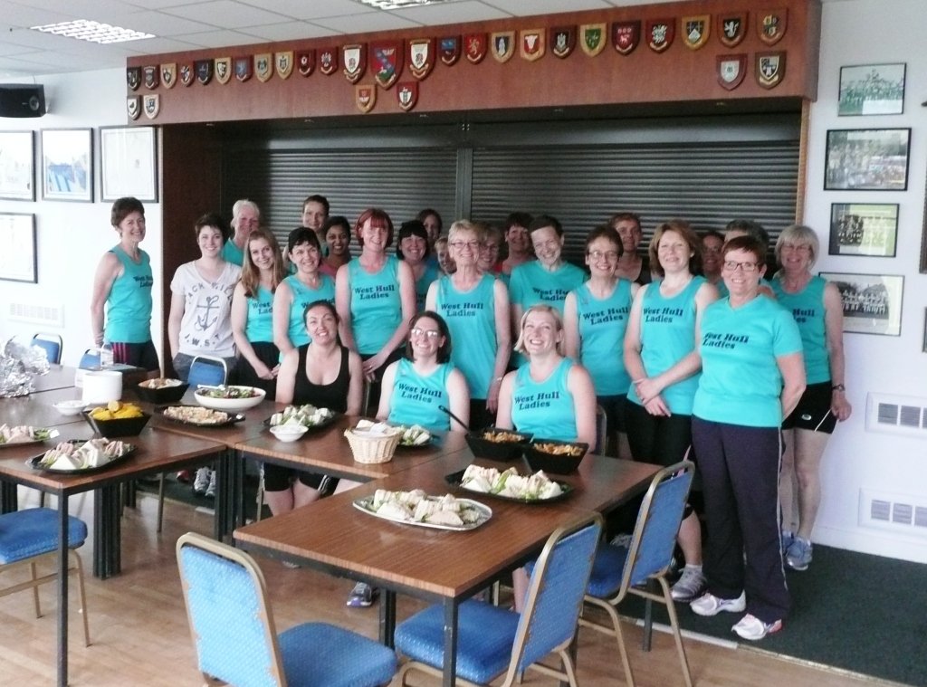

West Hull Ladies

Withernsea 5 miles

Sharron
Wow IT WAS HOT today!!!! Goodness me!!!!. There were a fair few people around to cheer the runners on, on this lovely sunny day, plus, we also had support from one of Ruth's work colleagues which was greatly appreciated, therefore we were relaxed from the off, he was there to see us finish also, so that was nice.

Anna, Jane, Ruth and I set off together. We all jumped when the horn went to signal the start, I think.....I THINK we weren't expecting it due to the fact we were all chatting happily away (and...er....having the usual photo sesh).

We all ran the first half mile or so together, in a row. Then the narrowing of paths forced us to split into two's, Ruth and I the front pairing, Anna and Jane following close behind (I know this, because every so often I could hear them talking)! And this is mainly how this run carried on.

It was hillier than I thought it was going to be. They were not big hills to tackle by any means but in this heat it was enough for my legs to say......whoa.....hang on a sec....who put these here....I DON'T DO HILLS!!!

We were very thankful for the water stations, they kept us going. We'd set off at a good pace Ruth and I, we were quite determined and this showed as Ruth thought we'd run the first 3 miles in around 30 minutes. It seemed a long slog between miles 3 and 4, but after hitting the 4 mile marker we settled down again and even picked up speed the last half a mile. The run in to the finish felt as though it lasted FOREVER. I could feel Anna and Jane right behind us and I heard the announcer getting really excited about a battle of the WHL to the finish line! That was so funny; I've never been involved in a battle to a finish line in my life!! Jane was the 'victor of the battle', I could hear her getting closer and closer to us and then all of a sudden; there she was, by the side of us, overtaking, well done Jane! It was fitting that we all came in just about together as we'd stayed together the run round. Boy, did WE all enjoy the reward of our fish and chips (in my case just chips) afterwards.

Also, just to say: All 4 of us were wondering how Ann was doing, as we set off for our run, on this hot and sunny day, I really hope she got on OK in her Iron Man Challenge, we were thinking of her.

Ruth
Another race day, another self-interrogation: Why am I doing this? Am I mad? I'm intending to race on a day when, as people in some parts of Yorkshire would say, 'it's cracking t'flags' (i.e. boiling hot). However the thought of a tee shirt and free fish and chips got me out of bed and ready to face the day.

No race report of mine is complete without several references to my running buddy Sharron, and this is no different.......so I picked Sharron up (see what I mean) and we made our way somewhat haphazardly to Withernsea. Once there we saw Anna warming up (I can never do that), then spent a while chatting to Mike, a work colleague of mine who lives in With and had come out to support us. There were people from several clubs - including the somewhat exotic locations of Halifax, Barnsley and Lincoln. I had hoped that if it was a small field I might win the prize of first female over 55 by dint of being the only female over 55. Unfortunately that dream was soon dashed as there were several ladies over 55 – drat.

After waving to Anna's family (out en masse) and having our photo taken by Anna's hubby we set off at the back of the pack - almost literally as there was only one runner and the 'last man marshal' behind us. Sharron and I are comfortable being at the back - I suspect Jane and Anna less so. Anyway there was a lovely sea breeze as we ran along the prom, however as we cut inland it got a bit warmer and a bit harder work. Sharron and I were running fractionally in front of Jane and Anna and you can tell we were taking it seriously because we weren't talking (much) - just to check we were ok etc. The first mile was fine because of the sea breeze and the fact that we were running through residential areas (i.e. something to look at), the 2nd mile was harder because we were in the countryside, and it was just that - countryside - the 3rd mile was ok because it had the drinks station at 2.5 miles and drinking water and pouring some over my head gave me a bit of a distraction, but the 4th mile was straight up the main road and really hard going in the heat. Another of my work colleagues saw us toiling up the main road as he drove past. I suspect we did not look our best. The final mile was not too bad - a bit of wiggle and back on the prom. Jane (the cheeky little minx!) came roaring past us at the end to beat us in. Well done Jane. In fact, well done to all 4 of us.

There was a lovely welcoming committee of family and friends waiting for us. Then it was the usual chatting and stuff while drinking copious amounts of water and orange juice, I swopped my black race tee shirt for a blue one and Sharron swopped her blue one for a black one (don’t ask!), then on to the chip shop with me nearly tripping up over some pavement sculpture in full view of the queue (whoops), Sharron had a nice chat with the bloke who came last (if he was last how come he was in front of us in the queue?) Sharron as a vegetarian could only have chips – no fish alternative – back to the car to finish our fish (me) and chips (both) and demolish other associated snacks we had brought with us, then home.

So conclusions
I like the fact that we ladies all just got on with it and put in a workmanlike race despite the weather – nothing spectacular (except for Jane at the end). Running other races in warm weather holds less fear for me.

I applaud Ann, Amanda and Verity for their sheer determination in doing endurance events in such warm weather, and those wonderful ladies who kept them company.

Would I do it again? Probably if my running buddy were doing it too. ☺

Outlaw Ironman Triathlon

Ann
Preparation
We camped all weekend, and renting a caravan that was conveniently delivered to our pitch. Good job we did, I hadn’t expected to have a son with a broken leg to add to the mix! Friday was spent eating at the pub down the road with the pirate posse I’d met at the DIY half ironman in May. Saturday was busier than I expected – registration, race briefing – “its going to be hot, real hot”, they said, don’t over inflate your tyres, take salt tablets, drink loads, but not just water. So off to the expo to buy electrolytes, because I hadn’t brought any and mistakenly thought they’d be in the energy drink.

When I got back to the caravan, both tyres were flat ... back to the expo to buy more inner tubes. Getting a bit stressed now – time’s getting on, and I’m not resting very much. Tyres on, wheels on, back to the centre to rack my bike and hang up my transition bags, packed more quickly than I wanted.

Race Day
Very little sleep, but that’s ok, because I’d banked some hours the week before to make up for this. I’d fretted about my tyres so got up at 3.30, and after sweeping up my spilt porridge from the floor I forced it down, in between picking bits of grass and fluff out of it (yes, minging, I know, but food is vital fuel in a day like this, grass or no grass), I went off to transition to check the tyres and pump them up ready. The lake was awesome – I knew I would feel overwhelmed by the size of it, but I was calm and enjoyed the time to get ready slowly

Swim
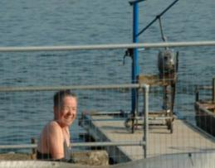
The countdown started, and a voice behind me said, “cr*p, my goggles have just snapped”, sorry mate, I’m in the zone ... the hooter sounded and I was off. Not too much pushing and shoving, but I was in the slowest pen – just concentrate on following the guys in front. The water was not pretty – I’d been warned about the duck poo, but, well – I didn’t swallow even the tiniest bit in this open water swim!! I settled into the best rhythm I could find, using all my letters from my pool sessions F=feel the water, G= glide, H=hips high, not sure I made it through the full alphabet. What joy to get to the big orange buoy – the swimmers bunched up a bit here, which made me feel part of the race again. On the way back I started drafting a bit more. One was swimming all over the place, so I left him to it and hitched a lift with another swimmer almost the entire way back. Thanks mate – and I’m sorry if I put you off your stroke keep catching your feet.

Out in 1:35 and thrilled with my 6 min PB. Great too to see Sandra, Vicky and my family cheering me on with such enthusiasm.

T1
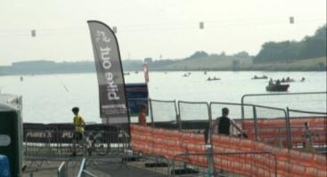
Quick change and out, I thought – until I found my bike with a flat tyre. Grrrr – get it together, get it sorted. With some help from a marshal it wasn’t too long before I was back on my way, but frustrated to have lost that good swimming time.

Bike
Once round the lake and then it’s time for second breakfast – cinnamon and raisin bagel with peanut butter, then off onto the main business of the day. 16 miles and it’s the pirate feed station. For those who don’t know about pirates – they are a fab bunch of people who see the fun side of triathlon. The approaching signs said, “High 5 - £3 a bottle”, “Bike sale 3pm”, “It’s not a knitting club” – this is for me what sport is all about, take on the challenges but remember to enjoy yourself along the way.

A few more miles along the way and puncture number two. Now my day took a downward turn. The tyre came off ok, and I checked it all over for debris, put the new tube in, but couldn’t get the CO2 pump to work. It looked as though the top of presta valve had broken off inside the pump. It was my last spare and it was broken. Game over. I sat on the side of the road whilst the rest of the field passed by, some making meaningless comments like “Have you got what you need?” hoping my answer would be “yes”, because no one had any intention of stopping, and I didn’t expect them to.

I wondered if my little hand pump might be any good. I didn’t have the strength to pump it up to full pressure, but it might get me a bit further. Success – off once again. Not only that, but the marshal at the next junction had a spare tube – my luck was turning...

20 more miles down the road and my luck ran out, as did the air in my tyre ... this time the marshal at the junction claimed he couldn’t help and watched as I struggled to get the tyre back on the rim. He relented and helped me get it back on saying the feed station was a mile down the road where they’d have a track pump, so I limped on. Luckily for me there were a couple of pirates lending a hand at this feed station who felt my pain, gave me yet another spare tube, but after noticing the tyre wasn’t on the rim properly turned to plan B and swapped the wheel over for one of Slagiatts (thank you so, so much – you saved my race).
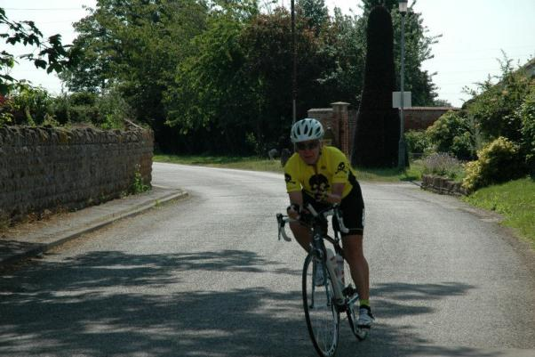
I was off – again, but this time at the back of the field, cycling strong but battling my mental challenge of seeing everyone finishing the north loop while I hadn’t even started it. My maths was telling me I had time, but it was a lonely ride, and even my food became a chore, not a pleasure. I kept to my eating schedule, though – I was determined to do what I’d planned for as long as I could.

Returning to the south loop for the second time meant another visit to the pirate feed station, and this time my family were there – but Carol’s arm was in a sling, I’ll get that story later. Meeting Sandra on the way back was a real boost too, especially when she poured water down my back! This was followed by a fall on a tight gravelly bend, but I was ok so jumped straight back on, knowing I was cycling strong enough and fast enough to beat the cut off with at least 15 minutes to spare. I prepared my “don’t stop me, I’m going to do it” speech every time I saw a race official ... but no need, the miles went by, I stayed strong and positive and made it back to base.

T2
Quick change and a banana, but a steady walk out of the change tent, wondering what the next stage would bring.

Run
Ha – ‘run’, well it was optimistic at best to plan to run between feed stations (1.3-1.9 miles apart). I ran to the first feed station, but then fell apart – I couldn’t even stand upright, and I couldn’t face anything other than water, and yet I knew I needed to eat ... I didn’t even know what to ask for, so had a few crisps and then hobbled on a bit further. It was all going very, very wrong. I wasn’t well and this wasn’t going to be remotely fast enough, even with 7 hours to play with ... I found a few lady pirates and confided my worries. Fraggle gave me a hug and they all said I had loads of time. I thought, “It’s not time, I need, its strength and energy and a belief that I can even get round the lake again.”
I knew I was finished, but just wasn’t sure what would happen next. Every time a medic went by I longed to be spotted as suffering from heat exhaustion, or something and get pulled, but they all seemed to be heading off to see someone else. I couldn’t work out when to quit. I decided I wasn’t going to quit, but wondered how long before they’d realise I wasn’t going to make the cut off and pull me from the race. How far could I run and not feel bad about collecting my sponsor money? More than 4 miles, definitely, so keep going...

I changed my strategy to run a mile, walk a minute, take whatever time is needed at the feed stations, and see I could average 15 min/miles. This would be enough to beat the cut off, with a buffer at the end for falling apart even more. This seemed to be manageable., so I kept going a bit more, aiming this time to at least do 10 miles, this, would be enough to collapse, but still collect my sponsor money with a bit of respect. I changed this plan to a half marathon...

... I was doing better than 15 min/miles so each mile was creating a more of a buffer later on. I was doing lots of sums and starting to wonder whether a finish might be possible. Then I met Sandra and niece Vicky at the feed station, and after a hug and cold drink continued on, with a bit more confidence.

Passing the pirate posse near the finish chute as I passed it by for yet another lap more than made up for the drain of hearing “You are an Outlaw” time after time for those already finishing. Loads of cheers were for me – I punched the air and kept going.

On the second long lap I met my good friend again, and chatting about this and that made the miles drift by until my maths was telling me I could now actually walk the remaining 6 miles and still finish in time. The pressure was off, I was going to finish. I ran a bit more ... and then a bit more...

... And then two pirates came to meet me to bring me in ... what a wonderful bunch these people are!

And so to the finish line – 16 hours and 21 minutes later I had a quick hug from Carol and my dad, and then pushed my son across the finish line. As the last pirate home it was a hero’s welcome – I felt like I’d won, and I guess in a way, I had.

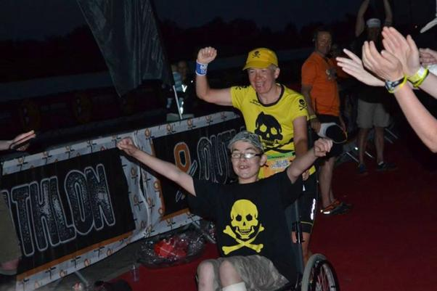

Walkington 10k

Linda
My first 10K wearing the West Hull Ladies vest. It was a very hot and humid evening. I think I set off a bit too fast, not really knowing the course although I was expecting a big hill and sure enough there was one ahead! I have a fear of hills, I am trying to overcome that and it is working although very slowly. I didn’t walk as much as I thought I would, got tucked in and just looked at the ground and was able to run some of the hills. Running down was no problem, I love downhill running but to run down you need to go up first so lots more practice at the Humber Bridge with Amanda’s help!

Well I finally finished, by now I was totally wet through and feeling a little uncomfortable. My finish time was 1.00.10 (chip time), and although I really wanted to dip below the 1 hour range I was happy with that as my Humber Bridge run (without all your help) was 1.02. To make my night Amanda took a look at my finish time and told me I had come 3rd in my age category (55-59) so was well chuffed. I’ve since looked on the web site and it appears there were 11 of us in my age group so I am very pleased with my result.

Next 10K Elloughton, with some more training maybe I can get my wish and dip below the one hour mark.

Thanks for all the encouragement.

Big G 100k Cycle Sportive

Deb
An epistle on doing a sportive for the 1st time. A new experience!

In horseracing terms I am currently 'broken down' and when that happens fillies (young female horses) usually go to Stud. Sorry, think I am flattering myself calling myself a filly, more like a crabby old mare and have done the Stud bit anyway and getting too old for that now anyway. Thus I have an injury that will probably take a while to fix and will always cause problems so, for horses, quite often a change of career, activity is recommended which, for me, has been flogging myself plus bike up and down the Yorkshire Wolds as it is slightly less painful than trying to run at any more than a steady jog.

I have always had a bike of some description having had to use one to get from a to b when younger, usually without gears and with a very heavy frame. I have continued to cycle and use my 15yr old Dawes road bike to cycle to work. My work colleague, a keen cyclist suggested I go out with her to 'get to know the Wolds' which I have been doing clocking up 30-50 miles once maybe twice a week. There may be very few hills in Hull but don't be deceived. Once you've literally crawled up Nunburnholme you will be crying out for the bowling green flatness of Hull even though the roads are more patches than tarmac. It was my colleague's idea to enter the Big G and I was able to get a late entry for the 100km so after a very early start on Saturday to walk the dog I cycled over to Beverley, met up with my friend and made our way to the venue, starting just before 8am. I must add here that I am indebted to Jill and Zoe who were also riding for giving me a lift back to Hull as I was going to cycle back once I had finished my pie and tea which the organisers provide and very nice it was too. I was also able to keep it down too, something I have struggled to do after running.

I was overwhelmed by the number of people who were taking part and by the number of very expensive bikes on show, usually owned by men who had all the gear ... I will let you finish the rest of. The event was extremely well organised and once I had my number with timing chip we ventured forth. My friend was doing the 160km but we rode together until the race split which was reassuring for me although we were quite often riding alongside other cyclists, some friendly in that they would say good morning, others not.

The route itself was a constant roller coaster of ups and downs with the ups seeming to get harder and longer as the route progressed. There were however some amazing views and I went through some beautiful peaceful countryside although towards the end of the race I wasn't taking that much notice, it was head down, keep the legs turning and where's the bloody finish. My bike has quite a hard saddle and had developed a slightly worrying bump every time the front wheel went round so my bum is quite sore today and my arms and shoulders seem to be stiff and ache in places that they never have done before. I think I might need a new front wheel - or a new bike - (how long till Xmas) and my 'on-board computer' (impressed?? -sounds posh but only a £10.00) stopped working once the race started as is always the way so I had no idea how far I still had to go. I had cycled up by Nunbornholme (hill) but not actually up the hill itself although we had done some particularly vicious climbs previously to this on the route so my legs and my lungs had already been well tested by this time. Some of the other 'little gems' seemed quite gentle after getting up Nunbornholme and then there was the descent but what goes down has to come back up and it did, all the way to the end of the race. I had been aiming to get back within the Gold time which I think was 4 hrs 15m but my pace dropped off considerably in the last hour and there was nothing I could physically do to make my body respond, apart from throwing the bike over the hedge and looking out for a bus. There were times when it did cross my mind, believe me. Having done the odd marathon and tough guy runs I have had the experience of 'hitting the wall' which is what happened and I was aware that I should have eaten my malt loaf and Nak'd bar earlier rather than thinking, as usual, I could wing it. You can't and keeping energy levels and hydration levels up are extremely important.

So what have I learnt from this experience?

That I would do it again but next time make sure I eat more as I am cycling so to avoid running out of energy. Not a nice experience on a bike when there are cars going past.
I was pleased with my overall fitness but there is a difference between cycling and running. Cycling seems to give your lungs more of a blast going up hill.
Chris Froome deserves all the accolades he gets for winning the Tour de France as do all the other cyclists. Shame there is no women's tour though.
Cross training is a valuable tool to try and integrate into a training programme.
That I really need a new bike!!

Elloughton 10k

Sharron
Ruth and I arrived early at Elloughton which enabled us to meet up with the rest of the WHL, have our photo's taken and then watch the fun runners. We walked to the start line and whilst the rest of the WHL had wandered to the front, Ruth, Karen, Jane and I hovered at the back, we were chatting happily at the start, missed the countdown and had the starting horn blare out to remind us of why we were there!!! We set off well, maybe a little too speedy but we were all feeling good. Karen was out for a nice training run round, Ruth and I were just aiming to finish and get the tee-shirt! We settled in the order of; Ruth, me, then Karen running alongside each other and Jane slightly behind, we checked throughout the run Jane was ok, she was, she was tucked in nicely behind. Then, after around 2k, I realised that maybe this wasn't going to be one of my favourite 10k races but tried to put that negative thought aside and crack on with it. We overtook a few runners, only after Ruth had had a good chat with each and every one of them (It's Ruth.... it's what she does!) and sooner than I anticipated the 5k marker was upon us. It was probably just after that point that I started finding this run hard. The sun had come out to play and the inclines all of a sudden seemed much longer and harder and steeper - I felt there were more 'up' bits then 'down' bits to these inclines. At this point Ruth seemed to be 'in the zone' and was running very well, chatting every now and again. Karen also looked at ease with her running and her knowledge of the area was invaluable, helping me with how I tackled the latter end of the run. I think at around 7k we were forced to run in single file, and with Ruth leading the way we covered the next k confidently. We had an incident at around 8k when Ruth unfortunately caught her foot and went over, scraping her leg, BUT, ever the professional, she jumped up, kept calm and carried on. I found the run in after 8k very very hard, my legs were tired, the inclines seemed never-ending and I was very warm. But, with major encouragement from both Ruth and Karen I came upon the 9k marker....."Thank goodness, nearly there". Karen then advised us to drop down a gear to enable us to get our breath back for a good run in to the finish, after which Karen kicked and strode ahead, I tried but my legs weren't having any of it though with the last few strides toward the finish line I managed to increase my speed enough to have felt a little proud of my run in. I thank Ruth and Karen for keeping me going.

All in all, now I'm sat at home with my feet up writing this report I AM glad I did it BUT, as I mentioned, this particular 10k wasn't one of my favourites..... as I will then suddenly remember, next year, 2k in! And, being from Hull where hills/inclines just do not exist, even though I moaned about them I realise now I tackled each and every one of these inclines head on and ran up them all, compare that to the Beverley 10k when I walked up the hills. Upon reflection my overall fitness and stamina has greatly improved......now THERE'S something positive to take from the last few months of running.

Well done to all the WHL who ran and thanks to Annette and Sandra for their wonderful support, the shouts were very encouraging.

Linda
Since the Walkington 10K I’ve made the effort to ‘up’ my training being determined to beat the one hour mark for a 10K race.

After some very heavy showers, thunder and lots of heavy wind, the day turned out warm and dry but still very windy. Sandra had done a reccie for us on Wednesday nights training so we knew the route. No chip start for this race though so I decided to start from the front giving me a head start. Think that might have been a mistake as my first mile was completed in 8.5 mins, way too fast! Anyway I settled into a nice pace and was pleased to complete the race in under the hour ..... 57.21! At last I have beaten the hour. All thanks to being a member of WHL so thank you for giving me encouragement. You never know I might even beat that! Fingers crossed.

After I’d finished I jogged up to the other WHL to encourage them to the finish, it was lovely to see Ruth and Sharon running together along with Jane. Sharon had a beaming smile on her face so I could tell she was enjoying the race (or was that a grimace)!

Thanks go to Sandra too, she was a marshal and took some photos and encouraged us along the way.

Looking forward to Escrick 10K in August.

Ruth
The Elloughton 10k is not my favourite race – ok it’s flat (unless you are Sharron) but there is nothing to distract the slow runner like me – not so bad if you are fast because things just whiz by but when you are slow you need something to distract you like houses, shops, or even the odd bend or two. Running over the A63 is the main distraction.

Anyway, because my running buddy Sharron was doing the race, so was I. We arrived and immediately saw Linda who was under instruction to get near the front and try to get under the hour – really no cause for Linda to worry as it was obvious to Sharron and me that she’d do it easily. Then we started bumping into all the other West Hull Ladies and families - I so love this club because everyone (and I mean ABSOLUTELY everyone) is always friendly, positive and supportive. After the obligatory pre-race wees we all trotted off to the start – Sharron and I were giving Helen the benefit of our running experience but she wisely ignored it. We found Karen loitering near the back and she said she wanted to stick with us for the race – people say that but when they find out how slow we really are they quite often change their minds. But Karen, to her credit, stuck with us and was amazingly positive and able to point all the little foibles of the course to Sharron – I already knew them from bitter experience!

Anyway we got round, I followed a policy of treating it like a social and chatted to a couple of people (who both finished in front of us). I managed to slip on a corner (not advisable) and muckied my knee, grazing it slightly but nothing serious. I didn’t wash the dirt off – I kept it as a badge of honour – useful excuse if anybody thought our time was slow.

Karen wanted a big finish but Sharron and I just weren’t up for it – so she pulled ahead of us and then from nowhere Jane came charging past and beat us in (she did that at The Withernsea 5 too). Jane - this must stop!!!

Then photos, mutual congratulations etc – so what did I think? Not as bad a race as last time I did it, Linda was awesome and ran back at the end to help us in, Vicky just got on with it and had her dad and sister to support her, didn’t see Helen at the end but presume she found it ok, Karen looked comfortable, Jane showed iron determination to follow us all the way round and pull something out of the bag at the end, Sharron now knows why I don’t like that race, and Sandra was immense, marshalling encouraging, taking photos etc..............and in the fun run Jess, Oscar and Sebastian (helped by Mum Annette) looked comfortable.............not long before Xanthe is doing fun runs too

Oh and I achieved my 2 permanent race aims 1 – to finish and 2 – to get a tee-shirt (and it’s a pretty impressive tee-shirt too – might even be worth doing it again next year if the tee shirt is as good)

Champagne League

Sally
Having missed the 1st race due to work commitments, I was already feeling disheartened at the start line for the 2nd race back in a freezing April! I had no idea what I would be like running shorter distances, but coming to the end of marathon training, I began the league quite strongly.

Beverley Westwood was a tough race as i'd just ran the marathon, but it meant that I had a slow handicap for the next race; won the handicap & £15!!!

I found the latter stages hard; running both Champagne & Summer Leagues, & I’ve missed a lot of Monday night speed work which I think has affected my times.

I would definitely do it again, if only to try to get a t-shirt & for the 8.4 miler!

Jill
Last year when I did the champagne league I had a love hate relationship with it. I hated it at first and then grew to really enjoy it, so I was really keen to have a go again this year. It’s a really well organised event by City of Hull AC, and you get to meet lots of really nice people from the other clubs. This year it has been really nice as WHL has had 11 runners in this event, and what is also good about the Champagne League is that there are a number of competitions within the event including points and handicaps. This means that although people like myself will never be able to compete against the likes of the really fast men, I can compete in the handicap, ladies or points competitions on a level playing field as it is about your effort, consistency and personal improvement, rather than your ability to run really fast.

This year I was really pleased with my overall performance as I was faster in every run in comparison to last year’s efforts by between 9 seconds (Grannies attic) and 6 mins 56 secs (Beverley Westwood). As a team (Thunder Girls are Go – the return) with Zoe and Verity, we also did quite well coming 5th overall, just beating our other WHL teams, although we did win last year, but it is just nice running as a team member anyway! It was also great to see WHL runners do really well in various events, Sally winning Lockington and Zoe winning South Dalton amongst other notable successes. I was really pleased to be 8th in the handicap at Wauldby Green (and 2nd woman behind Verity) and 4th in the handicap at South Dalton. It was also brilliant to see Carol win both the Champagne league overall and the ladies points competition… even though she kept saying that she wasn’t any good at running, but this success obviously suggests otherwise showing that consistency and grit and determination can win though!

Can’t wait until next year to do the Champagne league again though…it has some great runs in lovely scenery amongst with lots of friendly and supportive people. I would encourage anyone to have a go, as long as you can commit to doing the events, can run up to 8.4 miles and as long as you don’t mind a few hills and a bit of mud sometimes…although this year there has not been much of that. The plusses are that you get to know lots of nice people and challenge yourself! (ps and you get used to going for a wee in a field without nettling your bum!)

Helen
After hearing feedback from last year's Champagne League I decided to have a go this year and I am pleased that I did. Unfortunately I missed one race to illness and another to work commitments so managed 8 out of the 10. Some weeks were tougher than others (found Beverley Westwood a real struggle) but the encouragement along the way was brilliant and enjoyed the experience of some off road running. I surprised myself by enjoying the longest run at Waudby Green the most! Well done to all the ladies that competed, especially Carol winning the handicap!

Zoe
I was very excited to be competing in the Champagne League again as I really enjoyed it last year. I was a little upset when I pulled my calf muscle 2 weeks before the first run and had to take it easy for the first race, but I still got a good time of 30:32 (only 12 seconds slower than last year). I was pleased with this as it was cold and the Hudson Way race had been later on in the series last year. Over the next 3 races, I made good improvement beating all of last year's times. This included my favourite race on Beverley Westwood where I improved by 2 min 59 sec to complete the 3.3 M course in 26:06. This was despite setting off up the hill far too fast - Amanda didn't pass me until I was 0.5 M into the race........the only time that I will ever be ahead of her in a race, lol!

Halfway through the series I tweaked my Achilles running up Spout Hill and was forced to walk some of the course. All of the other runners were so supportive asking me if I was ok and this helped me keep going. By this point in the league the weather had started to get very hot and humid (my worst nightmare conditions) just as the races began to get longer. Race 6 was South Dalton 5 M, a really nice route through a park of cows. Debbie and I ran together (or rather I tried to keep up with Debbie) in what I think is my best race to date. It was hard work and I think Debbie probably got sick of my comments....'I can't keep this up'....'I need to slow down'...'We are going too fast'.... Despite this I still had a sprint finish at the end and enjoyed the feeling that I had tried my hardest (beating last year’s time by 4 min 57 sec) and succeeded as I won the handicap for this race. I was then happy to finish the 6 M race and looked forward to the 8.4 M Wauldby Green race which is a really nice route that I always enjoy. The league didn't end very well for me as I had been suffering from an ear infection and wasn't feeling well for either of the final two races.

All in all it was a very mixed experience this year, with me having some really good races and some bad ones. However, it was so nice to have the support of the club and the other competitors and it is a really good experience that I would recommend to anyone who likes running off-road. The experience has really brought me on as a runner and it won't take me long to start missing the adrenaline rush of competing on a Tuesday evening.

Suzanne
I really enjoyed the Champagne League, I know I didn’t do all the races but the ones I did were enjoyable and I finished them. I felt stronger in the last race. It was really lovely to run somewhere different. The hills were killers, but I got up them somehow.

The staggered start in race 7 was different, leading from the front is not something I have done before, but nevertheless I enjoyed it.

Thank you to all the WHL ladies for waiting for me to finish and cheering me on, it certainly helped. Thank you to Kate and Mary for being ‘team mates’. I think I would like to do it again next year!

Amanda
Love how it’s not the fast ones that win most of the prizes. Even if I’m not getting points I am really pleased for other ladies. The Team race is brilliant.
Great getting to know people from other clubs.
Fantastic training. Tough (all races are tough).
Beautiful countryside, lovely varied routes, fields, woods, tracks, road, mud, grass:
- Hills R US: Love Spout Hill – yes really. Love the long one – Wauldby Green. Not so sure about Beverley Westwood.
- And undulations: South Dalton, North Cave, Hudson Way, Grannies Attic, Kiplingcoates, Lockington (fields and church yard one) all really nice.
By the end you are glad it has finished and can get your Tuesdays back again – and then you miss it.
Unless you are like ‘Bambi on ice’ as soon as you leave tarmac, I would recommend you give the Champagne League a go.
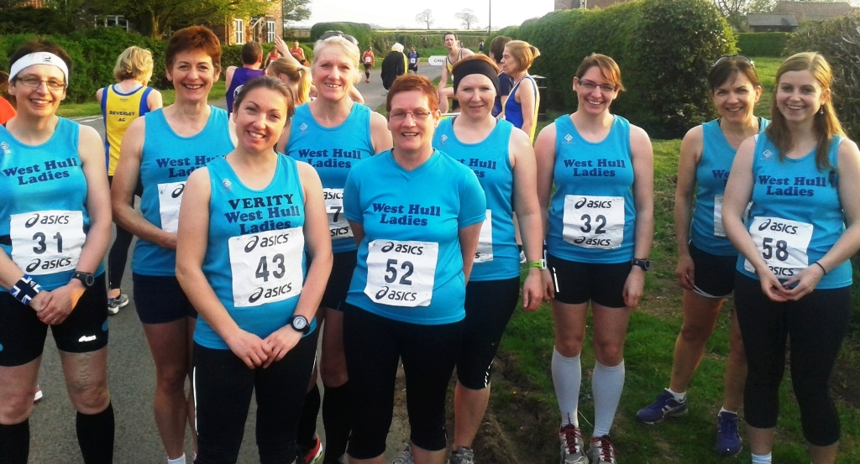

Racing and Running Events
Fancy something different? For worldwide marathons click here

Date/Time | Event | Fee | Entry forms | Online entry
August 2013
4th/09:30 | Jane Tomlinson's York 10K | £25.20 or click here for season ticket | Entry form to follow | Online entry
18th/11:00 | Escrick 10K | £10 UKA/£12 | Entry form | Online entry(+£1.40)
24th/08:00 | Smugglers Trod (26 or 17 miles run/walk) | £10 | Entry form | Postal entries only
September 2013
8th / 10:00 | Major Stone Half Marathon | £15 | Entry form | Online entry (+£1@UKforms.net)
29th/11:00 | College Canter (7 miles) | £8 UKA/£10 | Information | Online entry
October 2013
20th/12:00 | Bridlington Half Marathon | £12 UKA/£14 | Entry form | Online entry (+£1@UKforms.net)
27th/11:00 | Haltemprice 10K | £7 UKA/£9 | Entry form | No online entry
November 2013
3rd/TBC | Deepdale Dash 10K | TBC | TBC | TBC
3rd/10:00 | Yorkshire Coast 10K (Scarborough) | TBC | Entry opens soon | Online entry opening soon

Keep checking the website for new races and updates: www.westhullladies.org.uk/races.htm Verity, Racing Officer

NOTE: Club Vests must be worn at any races you enter
under the West Hull Ladies running club name.

Clubwear
PRICES:
Vest | £16.00 | All items are ordered on request and must be paid for at time of ordering. To place an order please print the kit order form and hand completed forms to Maria.
T- shirt | £16.50
Hoodie | £14.00
Jacket | £32
Beanie Hat | £6.50



New Club Jacket available in three sizes: small, extra small, and junior (large fitting). If you would like to purchase one please send a cheque for £32 to Debbie Watson, Treasurer, and state on the back of your cheque your name and that the cheque is for a jacket.

Jill

Running Library

You can borrow any of these books – they are upstairs near the toilets at the end of the corridor
Book List:
- The Runner's Diet (Runners World), Madelyn H. Fernstrom
- Paula My Story So Far, Paula Radcliffe
- The Runner's Handbook, Bob Glover
- The Competitive Runner's Handbook, Bob Glover & Shelly Lynn Glover
- Marathon Running For Mortals, John Bingham

- Lore of Running,

Running Magazines: These are available to borrow by emailing the club website.
Mark your email for the attention of Jo.

West Hull Ladies Road Running Club
Kit Order Form

FORENAME ___________________________________

SURNAME ___________________________________

ORDER - tick what you require, with size Price

- VEST SIZE _____________ £16.00
- T SHIRT SIZE _____________ £16.50
- JACKET SIZE _____________ £32
- HOODIE SIZE _____________ £14
- BEANIE HAT £6.50

DATE Ordered _______________

AMOUNT PAID _______________

Please make Cheque payable to ‘West Hull Ladies’
Write your name and order on the back.

Sign on receipt of goods _________________________________

DATE _______________

Please print this form, complete and hand to me with your cheque/cash.
Thanks.
Maria
Kit Officer

